Entity User Guide- ARPA Grant Management Portal
Active users can perform various activities (for example, submitting reporting and requesting payments) within the portal depending on their security role. This document will guide the user in submitting a report through the portal.
- Reporting (page 1)
- Payment Request (page 4)

Reporting through the ARPA Grant Management Portal

Portal Navigation

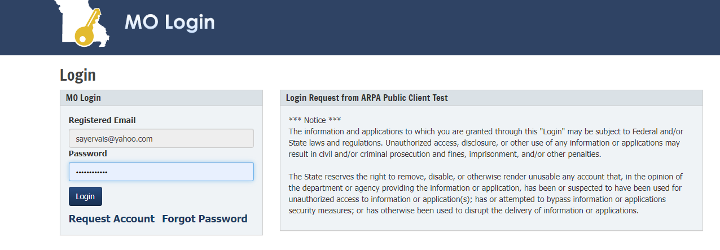
Users must log on by entering the registered email and password used to create their MO Login account
Xxx123@xxx.com

After completing the login process, the user can access the following by selecting from the left side menu bar: (see screenshot below)
- Home: Manage entity, users, files, or contacts
- Grant Applications: Create, manage, and submit an application; View submitted applications
- Project: View current projects; Submit reports; Request payments
- Redeem: Invite code (to join an entity) or register a new entity
- Exit

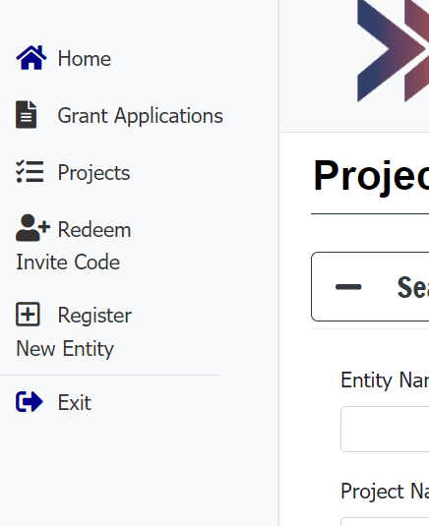
Next, the user should click the Projects link located within the left side menu bar to display a list of projects assigned to the user’s entity.

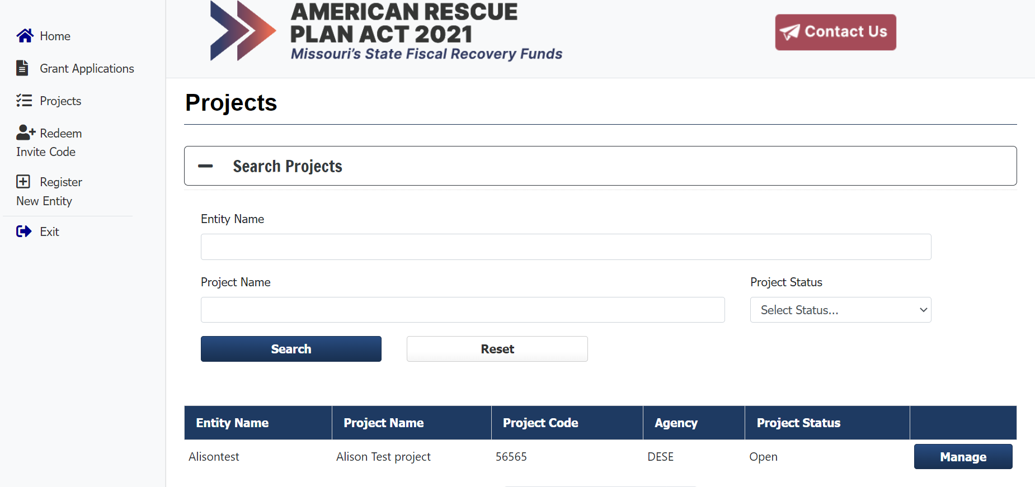
Once the project link has been selected, the project page will display.
To submit reporting information, request payment, or send messages: The user should click the Manage button to open the project and display options for reporting, payments or to send a message.
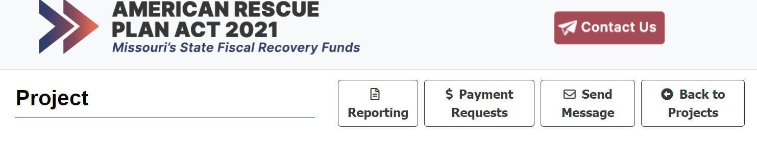
Once the Manage button is clicked, the individual project page will open.
To submit reporting: The user should click the reporting button

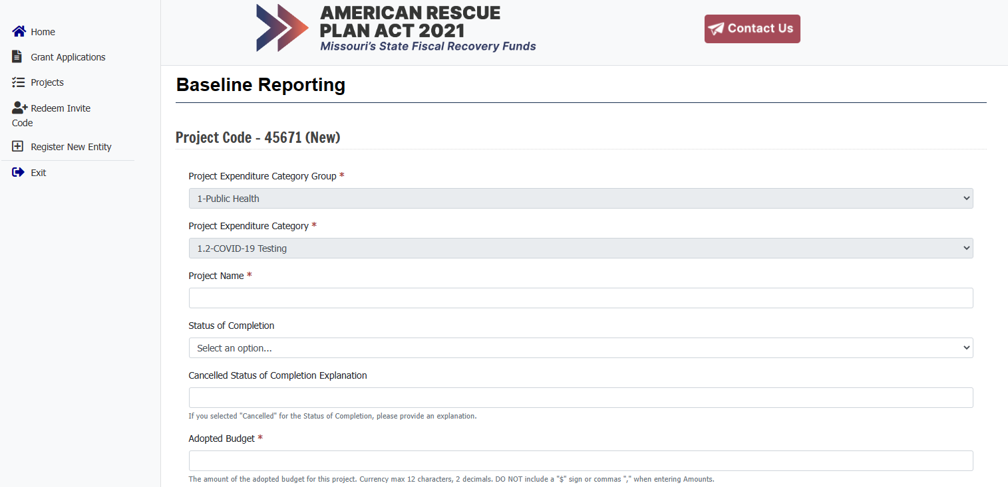

- When the reporting button is selected, the Baseline reporting document is displayed.
- The Project Expenditure Category Group and Project Expenditure Category fields will be prepopulated with the current project information.
- Based on the specific project listed, a list of questions to be answered will be displayed.
- Fields with a red asterisk denotes required fields that must be completed before submitting the report.
- The “$” sign or commas “,” cannot be used when entering a budget amount. In some cases, the amount cannot be a negative value.

Please note:
- The user must click the Save button to save changes to the report before exiting. If the Save button is not clicked, all changes will be lost. The report can be saved at any time before completion.
- To submit the report, the user must click the Submit button located at the end of the document. All report submissions are final. No changes can be made after clicking the Submit button.
- Data will be reviewed by the Department, and will be returned if corrections are needed.

For additional report submission assistance, please contact (insert contact information).

Payment Requests through the ARPA Grant Management Portal

Portal Navigation

Users must log on by entering the registered email and password used to create their MO Login account
Xxx123@xxx.com

After completing the login process, the user can access the following by selecting from the left side menu bar: (see screenshot below)
- Home: Manage entity, users, files, or contacts
- Grant Applications: Create, manage, and submit an application; View submitted applications
- Project: View current projects; Submit reports; Request payments
- Redeem: Invite code (to join an entity) or register a new entity
- Exit

Next, the user should click the Projects link located within the left side menu bar to display a list of projects assigned to the user’s entity.

To submit reporting information, request payment, or send messages: The user should click the Manage button to open the project and display options for reporting, payments or to send a message

To request payment: The user should click the Payment Requests button

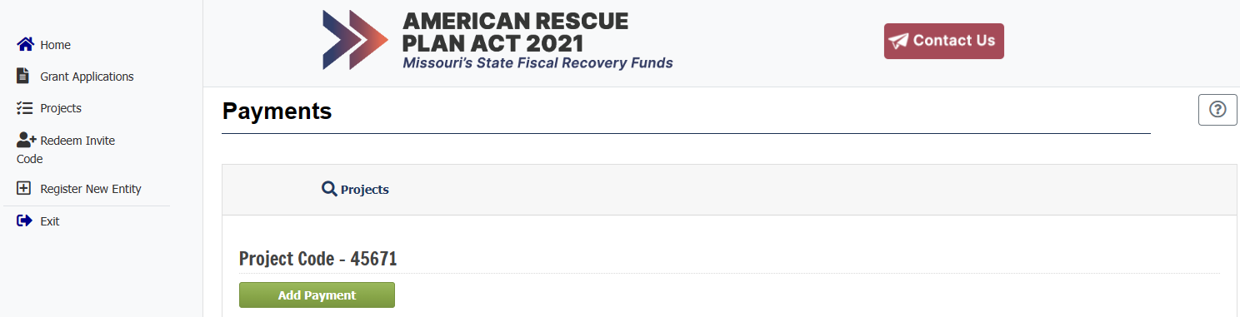
After clicking the payment link, the user can request a payment by clicking on the Add Payment button.

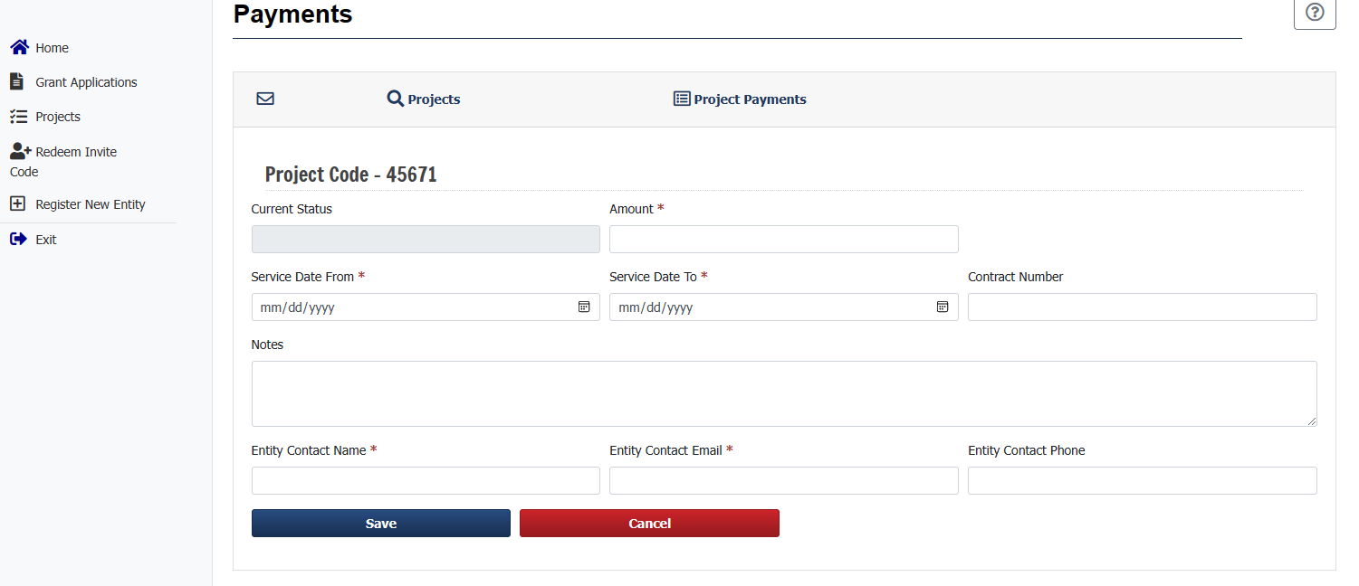
After clicking the Add Payment button, the payment document will display. A red asterisk denotes required fields that must be completed before submitting the payment document. The Current Status field will be blank when adding a new payment request, and can be left blank. This field will update once the payment request has been submitted. The user is required to enter the payment amount requested. The “$” sign or commas “,” cannot be used when entering the amount. Next, the user is required to enter the service dates.
Also, the user can enter a contract number and provide any notes regarding the payments in the Contract Number and Notes fields. The Entity Contact Name and Entity Contact Email fields will be prepopulated from the account who is creating the payment request. The user can enter the entity’s contact phone number in the Entity Contact Phone field.
The user must click the SAVE button to save changes to the payment request before exiting. If the save button is not clicked, all changes will be lost. The request can be saved at any time before completion.

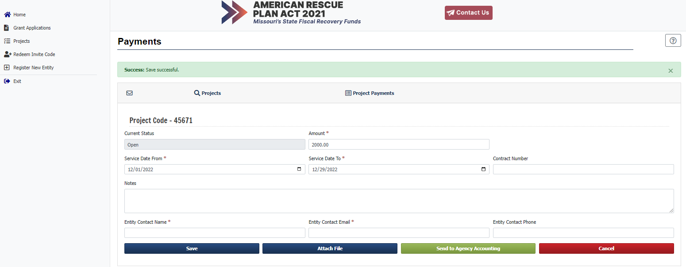

- To attach a file to the payment request, the user can click the Attach File button to choose the file to be attached.
- To submit the request, the user must click the Send to Agency Accounting button.
- If the Cancel button is clicked before information is saved, any new changes will be lost.
- All payment request submissions are final. No changes can be made after clicking the Submit button.
- The payment request will be reviewed by the Department, and will be returned to the entity for corrections if errors are found.

